**Name:**

**Automotive evolution**

**Exam on 2023/July 14th**

1. **Case study**

In a localization project in Argentina, it is required to machine a cylinder head.

**Volumes**: as per the picture below (k engine/year)

**Production pattern**: 250 days/year; 3 shifts/day; 7.5 hour/ shift

***Question #1:*** *Define for a CNC line*

* ***production capacity target*** *(…320 kupy………….)*
* ***production rate (jph****) (…57 jph………….)*
* ***cycle time*** *with efficiency 100% (s) (…63 s………….)*

***Question #2*** *The process analyst has given the following cycle per each operation: time, type and efficiency*

* *Op 10 150 s CNC 99%*
* *Op 20 180 s CNC 99%*
* *Op 30 220 s CNC 99%*
* *Op 40 45 s Washing 98%*
* *Op 50 50 s Assembly 99%*
* *Op 60 180 s CNC 99%*
* *Op 70 210 s CNC 99%*
* *Op 80 180 s CNC 99%*
* *Op 90 100 s Washing 98%*
* *Op 100 45 s Measurement 99%*

*Propose a solution with longer cycle operations with machine in parallel. How many machines we need? (………25…….) Evaluate the* ***efficiency*** *of the line considering no buffer between operations. (……88%……….)*

*Having that data evaluate the new* ***cycle time*** *to plan in the project: (……56 s……….)*

*Check if you need to add a machine due to efficiency. (Yes 3 machines for a total of 28…….)*

*Say which could be other solution and why.*

*(…Could be proposed a simulation to evaluate possible improvements given by some buffers in order to increase the total efficiency …………………………….…………………………....)*

***Question #3****: The investment of a Cyl. head machining line is 12 M€ (of which 4M€ in 2024 and 8M€ in 2025) and the cost is 150€. A supplier proposed an investment of 3M€ (in 2025) and a price of 180€. Evaluate the Make/Buy Business Case and the Make profitability fulfilling the template below (with WACC 15%):*



1. **Manufacturing technology evolution**

***Question #4****: Link each technology with the related automotive process and why.*

*Pairing and when useful why*

1111, ***1-c,2-b,3-d,4-e,5-a***

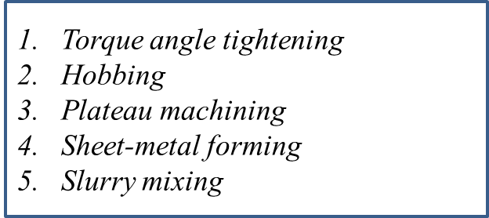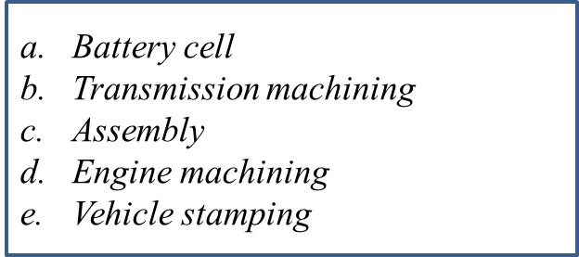

1c, 2b,3d, 4e, 5a

***Question #5****: Which is the Pareto law? Explain the application to Automotive Internal Logistics*

See theory

See theory